Feasibility of Using Haptic Directions through Maps with a Tablet and Smart Watch for People who are Blind and Visually Impaired

【Summary】：

Two prototypes were designed to test the user's ability to recognize maps using haptic feedback from Android smartwatches and tablets, and to track graphic lines and directions through maps on touch screens.

【Contribute】：

1. a proto-type with two cheap, off-the-shelf devices (a smart watch and a tablet) to determine distances between vibrating lines;
2. a comparative user study with this prototype between blind and sighted individuals that shows blind users have a better ability to determine distances through vibrational feedback from two devices;
3. a second prototype that uses more complex vibra-tional patterns from the same two cheap, off-the-shelf devices to perform map tracing;
4. a second user study showing both the feasibility and usability of the second prototype with blind and visually impaired users.

【Prototype 1】：

Our first prototype was designed to measure the ability of users who are blind and visually impaired to determine distance between two lines on a touchscreen using vibrational cues.

**Device：**Galaxy Gear Live+Nexus 10

**Method：**To specify different distances, the vibrations pulsate at different speeds. Slower pulsations are used to specify longer distances, and faster pulsations are used to specify shorter distances.

**Procedure：**Ask participants to compare two lines of different lengths and determine which of the two lines is longer. When the end point is reached, participants are notified by sound. After tracking these two lines, text-to-speech asks the user to respond. If the first line is longer, swipe left, and if the second line is longer, swipe right to record the response. Three conditions were tested: vertical, horizontal, and diagonal.

**Results:** The ability of blind and sighted participants to determine the distance between the two lines was measured. Lower distance thresholds in blind people indicate that they have enhanced their ability to form spatial distance representations from haptic vibration cues.

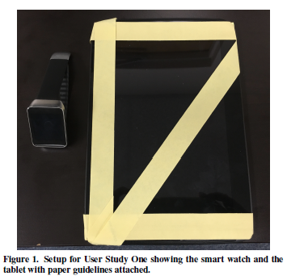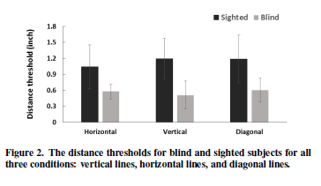

【Prototype 2】：

We attempted to further explore the following three questions: (1) Is it feasible for people who are blind to follow map directions based on vibrational cues alone on a touchscreen; (2) Can people who are blind understand and utilize complex vibrational patterns in a practical application; and (3) Whether blind individuals have a preference for certain vibrational patterns.

**Device：**Galaxy Gear Live+Nexus 10

**Method：**(For the introduction of specific methods, see PROTOTYPE TWO in the paper)

**Results:** (1) All users can understand and utilize complex vibration patterns. They can easily learn the vibration patterns of horizontal and vertical lines. Only a few times, it was difficult for participants to recall certain diagonal vibration patterns. For practical applications, good built-in tutorials and features that allow users to relearn complex vibration patterns will be beneficial. (2) Overall, participants like to use prototypes. Therefore, when both devices are vibrating, it is difficult for them to feel the vibration of the watch.

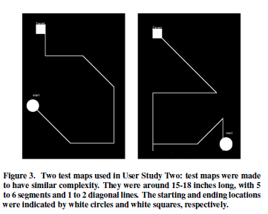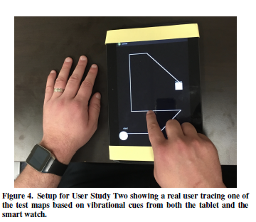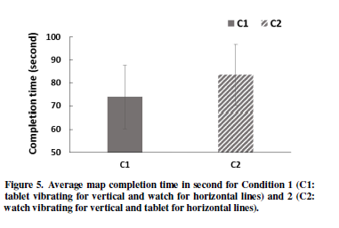

【Subjective analysis】：

The article uses the vibration combination of the two devices as a guide for map recognition on the device. Can this idea be extended to different device vibration frequency and intensity combinations for navigation of the map based on this idea?